Project Design Phase-II

Data Flow Diagram & User Stories

|  |  |
| --- | --- |
| Date | 28 October 2022 |
| Team ID | PNT2022TMID07573 |
| Project Name | Nutrition Assistant Application |
| Maximum Marks | 4 Marks |

# DataFlowDiagrams:

A Data Flow Diagram (DFD) is a traditional visual representation of the information flows within a system. A neat and clear DFD can depict the right amount of the system requirement graphically. It shows how data enters and leaves the system, what changes the information, and where data is stored.

Example:DFDLevel0

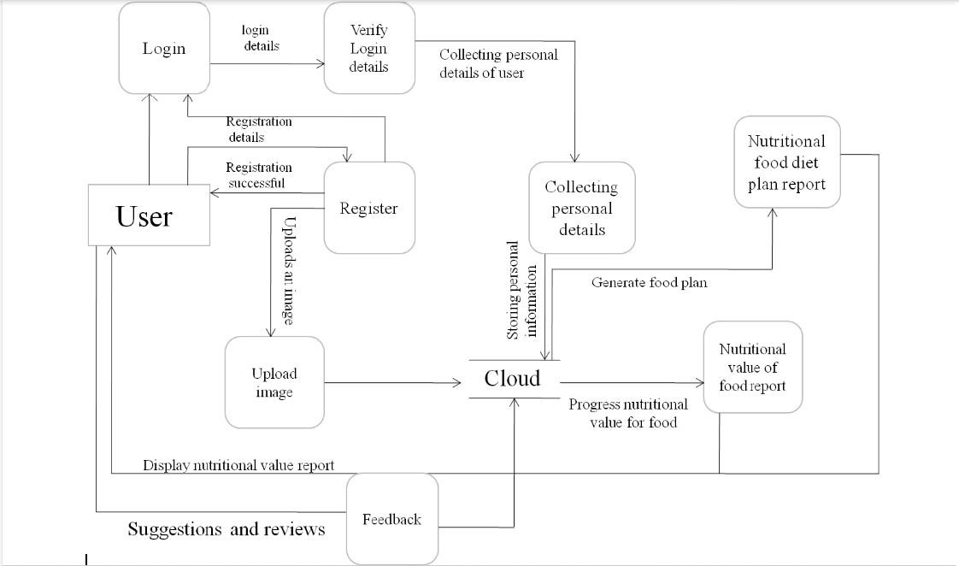

# UserStories

|  |  |  |  |  |  |  |
| --- | --- | --- | --- | --- | --- | --- |
| **User Type** | **Functional Requirement(Epic)** | **User Story Number** | **User Story/Task** | **Acceptancecriteria** | **Priority** | **Release** |
| Customer(Mobile  user) | Registration | USN-1 | As a user,I can register for the application by entering my email,password and confirming my password. | I can access my account/dashboard | High | Sprint-1 |
|  |  | USN-2 | As a user, I will receive confirmation email once I have registered for the application | I can receive confirmation email&click confirm | High | Sprint-1 |
|  | Login | USN-3 | As a user, I can login to the application by entering email &password | I can login when password and email are correct | High | Sprint-1 |
|  | Collecting personal details | USN-4 | As a user,I can provide a personal information for processing | I can enter the personal details | Medium | Sprint-1 |
|  | Upload image | USN-5 | As a user,I can upload an image for the processing of food. | I can upload a food image. | High | Sprint-1 |
|  | Feedback | USN-6 | As a user,I can give feedback | I can give feedback about the application | Low | Sprint-1 |
| Cloud | Nutritional value of report | USN-7 | In cloud, the food image is processed and provides the nutritional value of food. | It gives the nutritional value of food. | High | Sprint-2 |
|  | Nutritional food diet plan report | USN-8 | In cloud,the food dietplan based onnutritional value is  generated based on the personal information provided by the user. | It provides the diet nutritional plan. | Medium | Sprint-2 |